RENTING AND/OR BUYING MUSICAL INSTRUMENTS IN SANTA CRUZ

We encourage students to obtain their own instruments if possible. Here are some local shops where you can find quality new or used instruments.
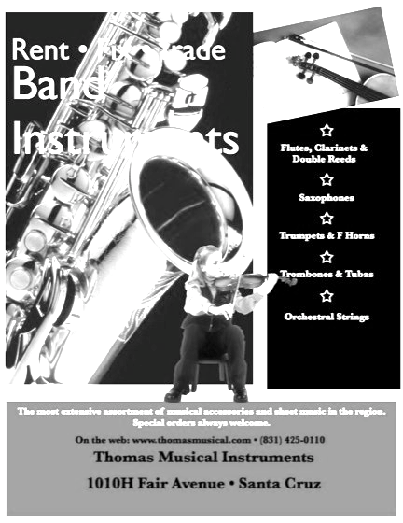
THOMAS MUSICAL INSTRUMENTS
http://www.thomasmusical.com
1010-H Fair Ave, Santa Cruz, CA 95060 Phone number: (831) 425-0110
Hours: Monday through Friday from 11-6, Saturday 11-5. Closed on Sundays.

Instrument sales, rentals and repair, sheet music, accessories and lessons. Focus on brass, woodwinds and instrumental string instruments. No ukeleles, banjos, mandolins or guitars.

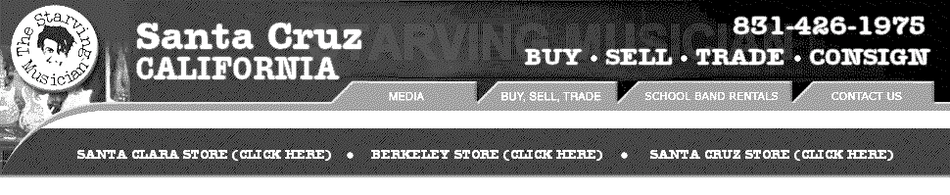
STARVING MUSICIAN
http://www.starvingmusician.com
1400 Ocean Street, Santa Cruz, CA 95060
Phone Number: (831) 426-1975

Hours:
Mon-Fri 11 am
7 pm, Sat 11 am
6 pm. Sun 12 pm - 5 pm

Rent (3 month minimum) instruments, Rent to own (optional insurance available), Buy (new or used), Sell, or Trade instruments, Lessons

UNION GROVE MUSIC
http://www.uniongrovemusic.com
1003 Pacific Ave, Santa Cruz, CA 95060
Phone number: (831) 427-0670

Hours:
Mon-Wed, Sat 10 am - 6 pm
Thu-Fri 10 am - 7 pm
Sun 11 am - 5 pm

Sales, rentals, repair, lessons and clinics.

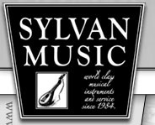
SYLVAN MUSIC
http://www.sylvanmusic.com
1521 Mission St, Santa Cruz, CA 95060
Phone number:(831) 427-1917

HOURS: Open Daily, Mon-Sun 11 am - 6 pm

Rentals, Rent-to-own, Repairs, Lessons

