Gold Choir Audition

Auditions will be held: Monday, June 3 and Tuesday, June 4
Westlake: First recess (10:10-10:30am)
Bay View: Lunch recess (12:20-12:40)

***Please practice on HaegerMusic.com and bring this form (filled out) to the audition.***
Name __________________________________________________________ School _______________________________________
Student’s Musical Experience _______________________________________________________________________________
_________________________________________________________________________________________________________________
I understand Gold Choir is a year-long commitment and reserved for students that meet the requirements. I believe I have the focus and commitment to be in a select choir.

Student Signature ____________________________________________________________________________________________

…..………………………………..For Teacher Use Only Below This Line……………………………………………
Matching Pitches: 4 3 2 1
Major Scale: 4 3 2 1
Melodic Patterns: 4 3 2 1
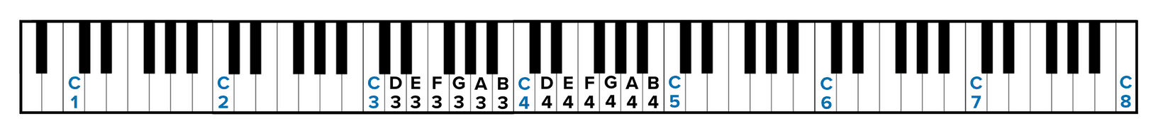
My Country ‘tis of Thee (1st verse, a capella): 4 3 2 1
Range:
Comments:
RUBRIC:
4 = All pitches and rhythm are performed accurately, clear tone, exhibits basic music skills.
3 = Most pitches and rhythm are performed accurately, mostly clear tone, exhibits most basic music skills.
2 = Some pitches and rhythm are performed accurately, still developing tone, basic music skills may be lacking.
1 = Few pitches and rhythm are performed accurately, weak tone, basic music skills are lacking.

