BAND RESOURCE PACKET
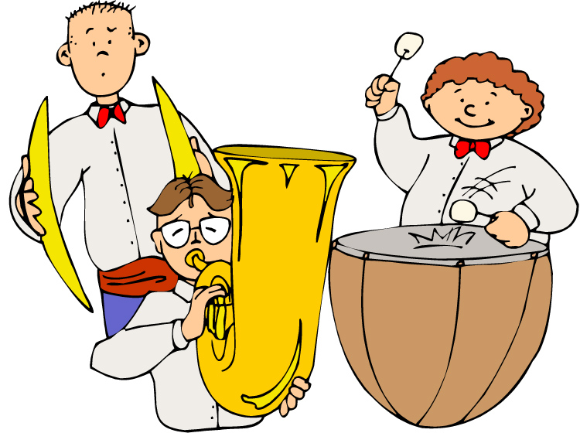
Please keep this in a place where you can access it throughout the year.

This packet contains:

- INSTRUMENT REPAIR: If you have your own instrument… where to get it repaired?

- INSTRUMENT RENTAL AND PURCHASE RESOURCES: Where can I purchase an instrument now that I know my child enjoys playing it?

I HIGHLY RECOMMEND purchasing from a local music store for the following reasons:

  - Quality (Amazon and Ebay often sell inferior instruments at cheap prices. These instruments will be in the shop more often and cost more money in the long run.)

  - Support (when you need advice or repairs, your local retailer is in the neighborhood and they often offer free or discounted repairs to those who purchase from them)

  - Support the local economy

- LOCAL MUSIC TEACHERS AND STUDIOS offering individual instruction on wind and piano instruments. Because I can only teach the basics to a large group, your child will benefit from having one-on-one instruction where they can refine their instrumental skills and come to band more prepared and confident.

Musically Yours,
Katrina Haeger
Bay View and Westlake Elementary Music Specialist
khaeger@sccs.net

